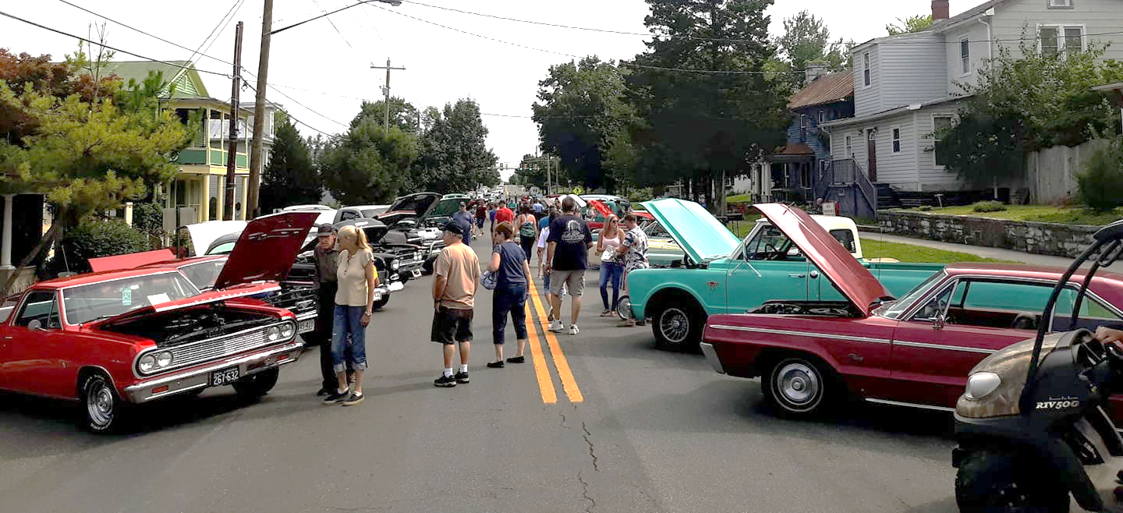

Middletown’s 11th Annual
Car & Truck & Tractor Show
Sunday August 15, 2021 • 10 a.m. – 3 p.m.
Registration 10:00 a.m. - 12:00 p.m. • Awards Presentation at 3:00 p.m.
Located on MAIN STREET in Historic Middletown, Virginia
Sponsored by
Entry Fee $10.00
Awards: Top 25 1900-1980, Top 10 1980-Present, Best Tractor
Dash plaques to the first 100 registered vehicles.
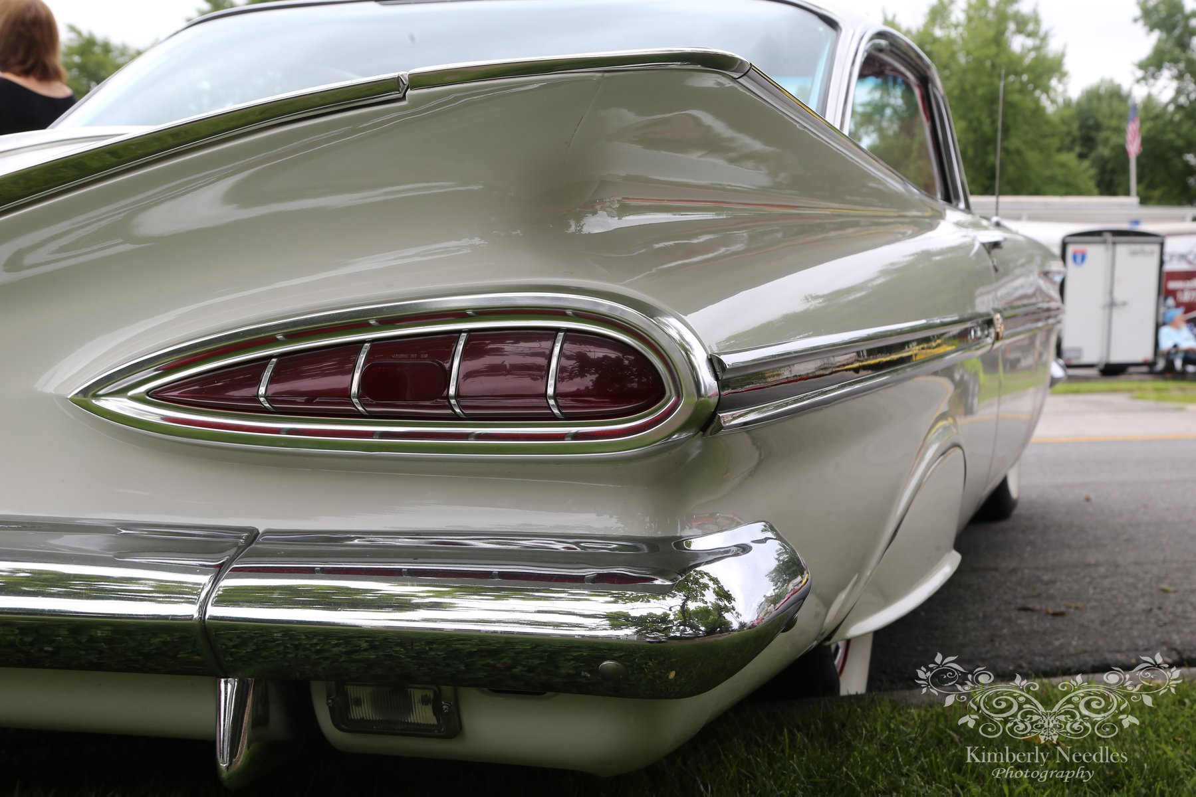
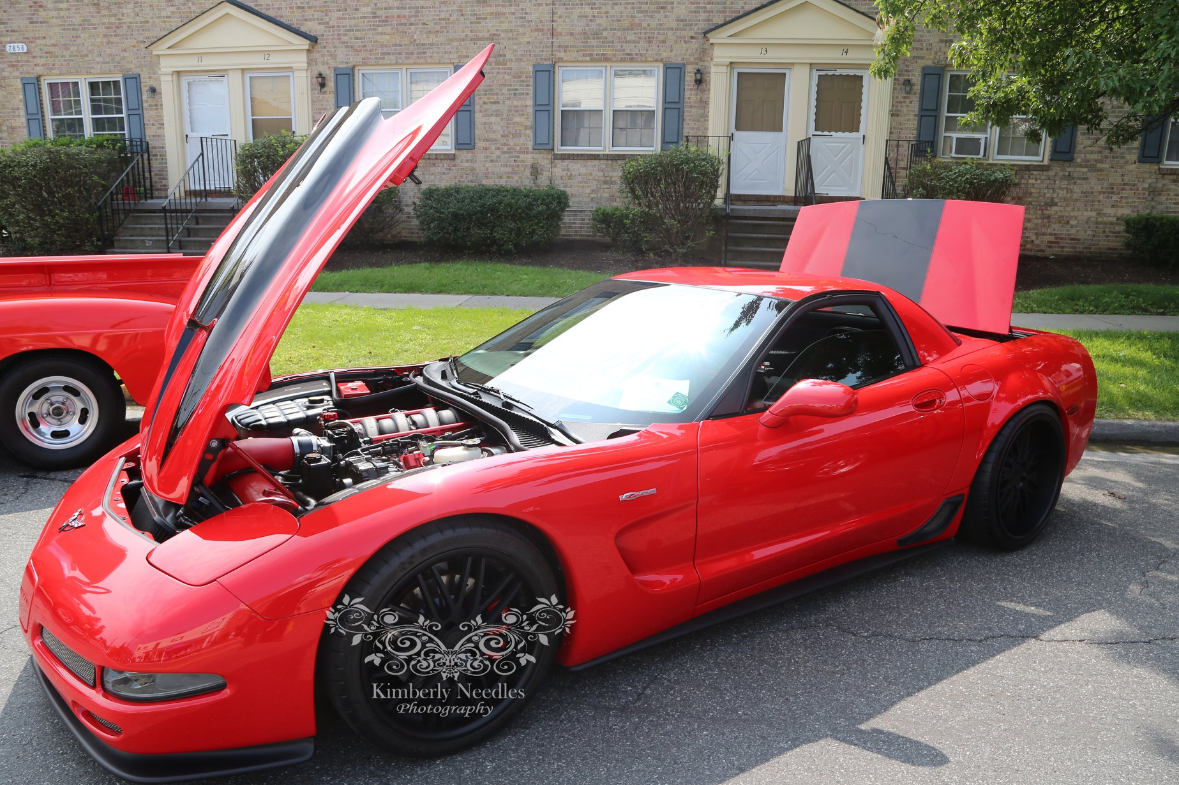
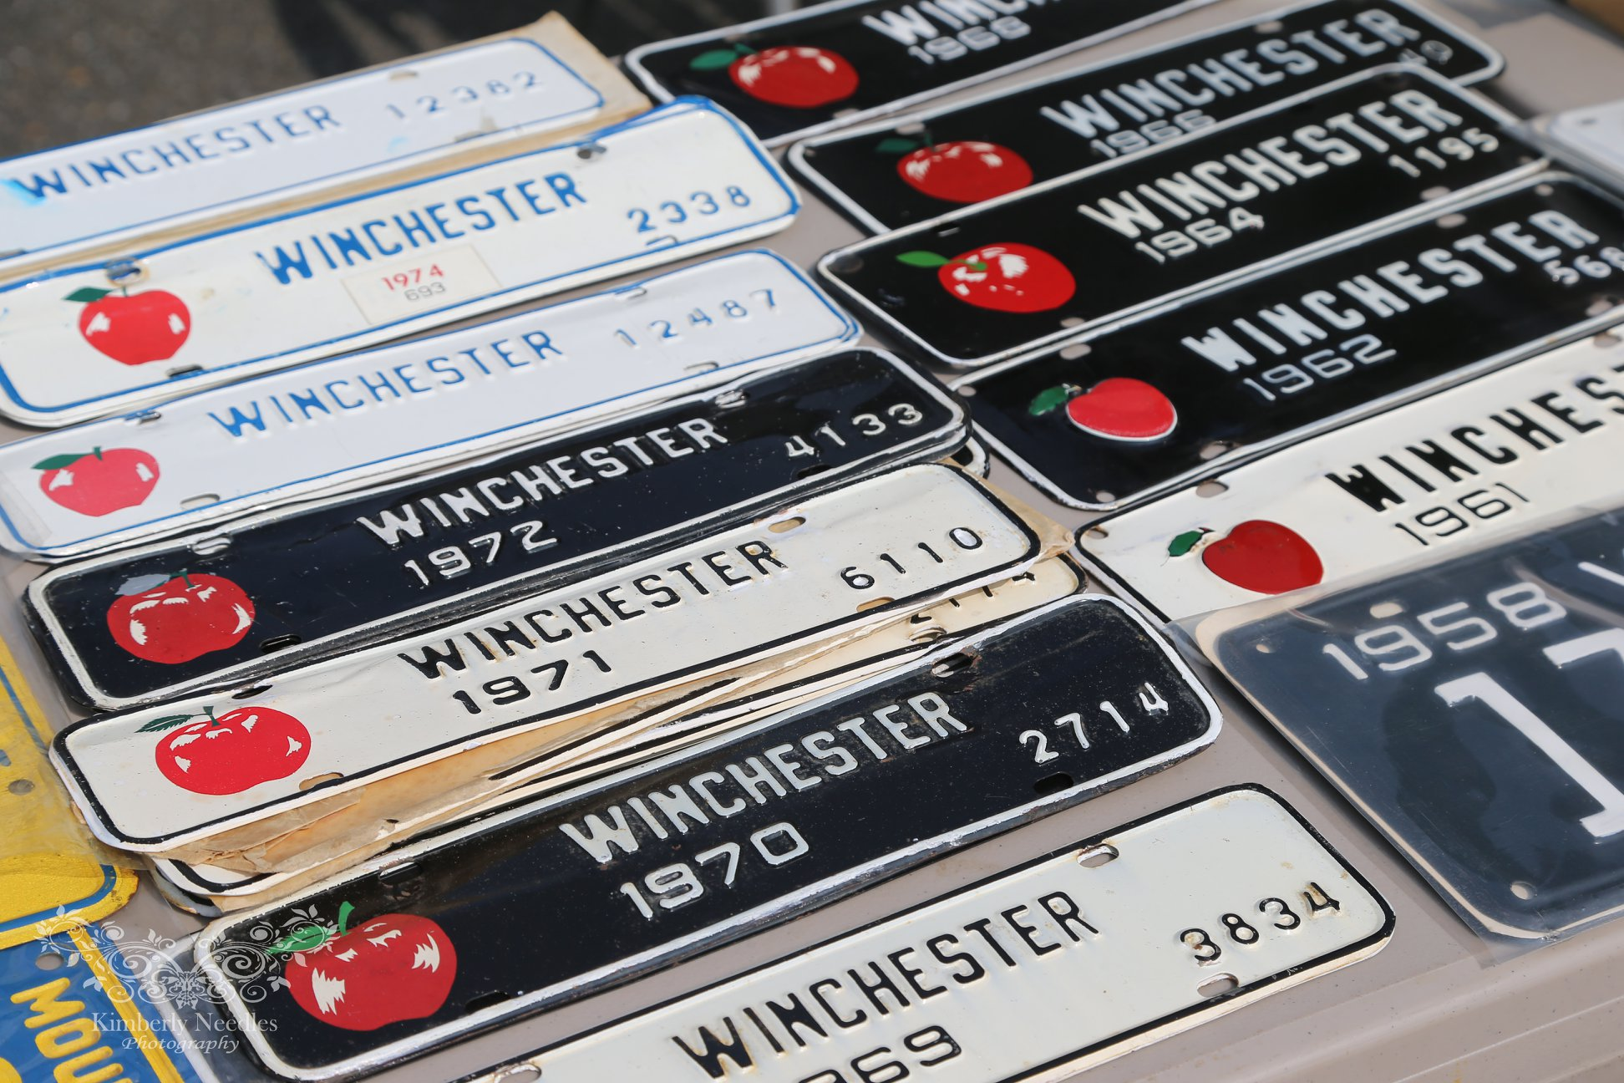

To benefit the Middletown 4th of July Celebration, no pre-registration required, any questions, please call Mayor Charles Harbaugh IV 540-877-4594. Rain Date is Sunday August 22, 2021.

