8th. Annual
PA Cruisers
Car and Truck Show
Memorial Day
Monday, May 30, 2022
Rain or Shine
Held at the Upton Community Center
Behind Stickell’s Store 5489 Buchanan Tr. W. Greencastle PA 17225
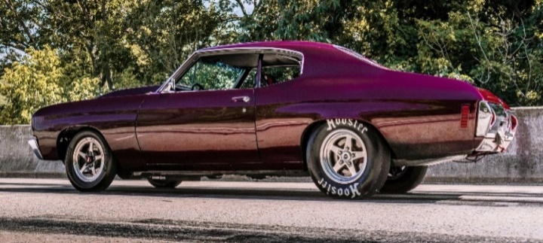
Registration: 8:00 AM to 12:00 Noon
Trophies given out at 2:30 PM

$12.00 Entry Fee ~ 100 Dash Plaques Food on site
Trophies – Top 45 Cars and Top 8 Trucks (2ft. Double Post Trophies) Boy Scout Troop 95
Best of Show Car & Truck Trophies 4ft. Tall and 10 Special Trophies Shade Grove, PA
50/50 Raffle Chinese Auction

Not Responsible for Accidents the day of Show

Contacts: Brian Mowen (717) 261-6019 and/or Ruth Knable (717) 597-7006
Please let a message for a return call for information

