Corpus Christi Church
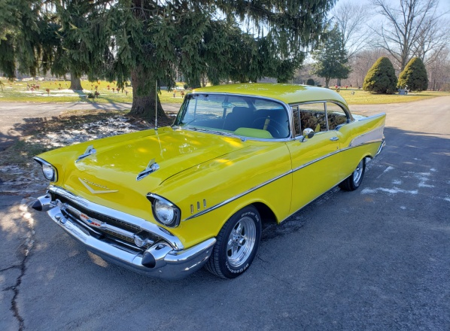
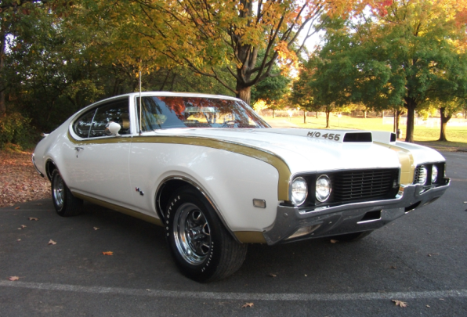
Cruise-In

Friday, August 20, 2021
279 N. 2nd Street Chambersburg, PA 17201
5:00 pm to 9:00 pm Rain or shine
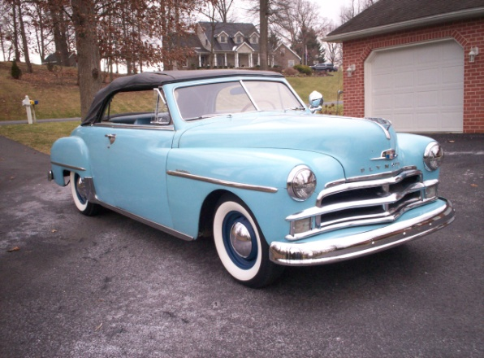
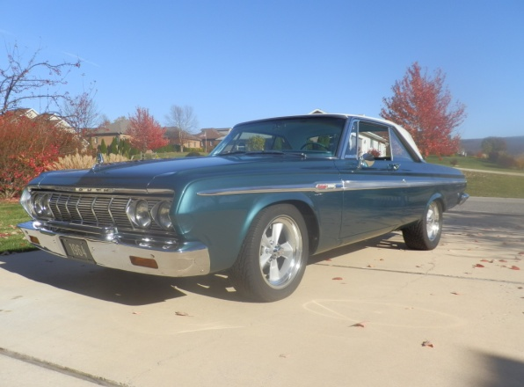

DJ playing tunes of the times!

Food and drinks available!

50/50 Drawing Door Prizes Chance Raffles

Registration: $10.00
(includes one ticket for
Dash plaques to the first
50 participants

Door Prizes)

Awards presented
at 8:00 pm

Pastor’s Choice Award
People’s Choice Awards
1st 2nd 3rd
Open to all vehicles

For more information call 717-263-9541 or email rramsey@corpuschristichbg.org
- - - - - - - - - - - - - - - - - - - - - - - - - - - - - - - - - - - - - - - - - - - - - - - - - - - - - - - - - - - - - - - - - -
Corpus Christi Church will not be responsible for any know/unknown damages, injuries, losses, judgments and or claims to persons or property while attending the car, truck and motorcycle cruise. No alcohol, burnouts, playing stereos, bicycles, skateboards, scooters, or pets (except service dogs).

